 

Republika e Kosoves / Republika Kosova / Republic of Kosova

Komuna e Podujeves Opstina Podujevo Municipality of Podujeva

RAPORTI FINANCIAR PER PERIUDHEN JANAR-SHTATOR 2024

Tetor 2024

Raporti pasqyron aktivitetet financiare qe jane kryer gjate periudhes janar-shtator 2024.

**Qellimi**

Qellimi i ketij raporti eshte te prezantohet nje pasqyre e aktiviteteve financiare te zhvilluara gjate nente mujorit te vitit 2024.

**1. Permbledhje**

Shuma totale e buxhetit fillestar te aprovuar per vitin 2024 eshte sipas struktures se paraqitur ne vijim:

* Paga dhe Meditje
* Mallra dhe sherbime
* Shpenzimet komunale
* Subvencione
* Shpenzime kapitale

**Gjithsej**

16,518,288 €

3,585,500 €

513,000 €

1,670,000 €

8,756,231 €

**31,043,019** €

I

|  |  |  |  |  |  |  |  |  |  |  |  |  |  |  |
| --- | --- | --- | --- | --- | --- | --- | --- | --- | --- | --- | --- | --- | --- | --- |
| **Nr.** | Emertlml |  | Drejtorls | | kodet | kodl- funks | stafi | Paga | | Mallra | Komunall | Subvenclone | Kapltale | Totall 2024 |
| **1** | Zyra e Kryetarlt | | | | 160/16005 | 111 | 19 | 178,693 | |  |  |  |  | 178,693.00 |
| **2** | Zyra e Kuvendlt | | | | 169/16905 | 111 |  | 256,820 | | 15,000.00 |  |  |  | 271,820.00 |
| **3** | Adminlstrata | | | | 163/16305 | 133 | 68 | 466,813 | | 264,794.50 | 318,000 |  |  | 1,049,607.50 |
| **4** | Buxhet dhe Financa | | | | 175/17505 | 112 | 22 | 178,823 | |  |  |  |  | 178,823.00 |
| **5** | Planiflkim dhe Zhvllllm  **(+3)** | | | | 480/48005 | 411 | 9 | 78,870 | | 50,000.00 |  |  | 808,554.38 | 937,424.38 |
| **6** | lnspektlmet | | | | 166/16609 | 411 | 17 | 173,148 | | 45,000.00 |  |  |  | 218,147.80 |
| **7** | Bujqi:isia | | | | 470/47005 | 421 | 21 | 138,050 | | 60,000.00 |  | 686,336 | - | **884,386.00** |
| **8** | Kadastrl dhe Gjeodezla | | | | 650/65025 | 610 | 19 | 151,056 | | 10,000.00 |  |  |  | 161,056.00 |
| **9** | Planiflkim Urban | | | | 660/66030 | 620 | 12 | 111,717 | | 100,000.00 |  |  | 2,314,470.12 | 2,526,187.12 |
| **10** | lnfrastruktur Publlke | | | | 180/18165 | 451 | 11 | 95,637 | | 890,000.00 |  |  | 2,364,211 | 3,349,848.00 |
| **11** | ZJarrfikslt | | | | 180/18225 | 320 | 18 | 153,449 | |  |  |  |  | **153,449.00** |
| **12** | Kultura Rini e Sport | | | | 850/85005 | 820 | 17 | 130,014 | | 80,000.00 |  |  | 470,000 | **680,014.00** |
| **13** | Teatri Avdush Hasani | | | |  |  | 12 | 120,585 | |  |  | 30,757 |  | 151,342.00 |
| **13** | **ZKK** | | | | 195/19725 | 1090 | 2 | 18,336 | |  |  |  |  | 18,336.00 |
|  | Adminlstrata (A) | | | | 920/92025 | 980 | 12 | 96,212 | |  |  |  |  | 96,212.00 |
|  | Administrata (SH) | | | | 730/73014 | 760 | 10 | 82,737 | |  |  |  |  | 82,737.00 |
|  | Sherblmet rezldenclale | | | | 75522 |  | 13 | 91,390 | | 45,000.00 | 5,000 |  | 280,000 | 421,390.00 |
|  | Shi:irblmet Soclale | | | | 755/75521 | 1040 | 13 | 101,207 | | - |  |  |  | **101,207.00** |
|  | Total! I-Gran.  Pergjith,shem - | | | | I |  | 295 | •.  2,623,557 | . | **1,559,794.50** | 323,000 | . .  717,093 | 6,237,235.50 | 11,460,679.80 |
| 14 | Arslm dhe Shkenc | | | | 920/911 | 912/922 | 1453 | 11,404,204 | | 1,152,000 | 130,000 | 89,243 | 1,500,000 | 14,275,447.00 |
| 15 | Shendetsla (QKMF) | | | | 730/73300 | 721 | 246 | 2,394,527 | | 822,706 | 60,000 |  | 170,000 | 3,447,233.00 |
| ' .• | -cc--:  total•l . | : | | --:  > | cc --: ..  . | --: ..  •.•. | -c  **1994** | --:  16;422,288 | | .  3,534,500.S'0 | •  513;000 | 806,336 | 7,907,235.50 | 29,183,359.80 |

TE HYRAT VETANAKE

|  |  |  |  |  |  |  |  |  |  |  |
| --- | --- | --- | --- | --- | --- | --- | --- | --- | --- | --- |
|  | Programet |  |  | Stafl | Paga | Mallra | Komunall | Subvenclone | Kapitale | Totall-2024 |
|  | Administrata |  |  |  |  |  |  | - |  | - |
|  | lnfrastruktur Publike |  |  |  |  |  |  | 100,000 | 162,659 | 262,659.00 |
|  |  |  |  |  |  |  |  |
|  | Planlflkim dhe zhvillim |  |  |  |  |  |  | 300,000 |  | 300,000.00 |
|  | Planifikim urban |  |  |  |  |  |  |  | 686,336 | 686,336.00 |
|  | Bujqesia |  |  |  |  |  |  | 13,664 |  | 13,664.00 |
|  | Kultur, Rini e Sport |  |  |  |  |  |  | 200,000 |  | 200,000.00 |

.

|  |  |  |  |  |  |  |  |  |  |  |
| --- | --- | --- | --- | --- | --- | --- | --- | --- | --- | --- |
|  | **Teatri** |  |  |  |  |  |  | 19,243 |  | **19,243.00** |
|  | **Arsim dhe Shkenc** |  |  |  | **47,000** | 28,000 |  | **30,757** |  | **105,757.00** |
|  | Shendetsla (QKMF) |  |  |  | 49,000 | 23,000 |  |  |  | 72,000.00 |
|  | **Admlnlstrata ( SH)** |  |  |  |  |  |  | 200,000 |  | 200,000.00 |
| **Tola!I I**  **THV** | •.  •, |  |  |  | **96,000** | .  **51,000** | . | **863,664** | **848,995** | **1,859,659.00** |
|  |  |  |  | .  1994 | **16,518,288** | **3,585,500.50** | **513,000** | .  **1,670,000** | 8,756,230.50 | **31,043,019.00** |

Ne tabelen e me siperme kemi paraqitur burimet e mjeteve si dhe planifikimin e buxhetit sipas drejtorive,per vitin 2024.

**Inkasimi i te hyrave vetanake**

|  |  |  |  |
| --- | --- | --- | --- |
| I 5,891 | I 589 | I 10,944 | I 120,945 |
| I8,803 | I9,378 | I7,914 | **I 65,462** |

Sa i perket inkasimit te te hyrave vetanake komunale,per periudhen janar-shtator jane inkasuar 1,655,772 € (299,313 € jane donacione te brendshme).

Tabela 3.lnkasimi i te hyrave vetanake 2024



1 I **dhe te biznesit/Lejet**I

**Licencat komerciale**

185

1184 I 3,395

I -

1111

I -

I 361 I 288

I 1,457 I 6,041

2

I**zbavitese**

**Licencat per lojera**

**Shfrytezimi I tokes**

1. I **dhe lejet e ndertimit** I

**Inspektimi I tokes dhe aktivitetet**

1. **J gjeodezike**

**Sherbimet e inspektimit te shend.**

_

I 1,896 I 96,301 I 11,556 I 111,434 I 5,846 I 16,833 I 50

I 31,214 I 275,131

111,244

112,192

112,204 I

9,754

111,564

I

9,293

**112,176**

116,311 I9,973

**1104,711**

**Pagesat ne lidhje me**

**7 I automjetet**

I50,825

I45,640 I41,996 I65,320 I60,932 I54,017 I20,590 118,491

**116,915** I

374,726

**<:;ertifikatat dhe**

1. I **dokumentet zyrtare**

**Taksa e prones**

1. I

6,631

8,394

**5,744**

7,341

6,799

**6,420**

**8,227**

9,233

6,413

65,202

22,514

20,460

17,356

53,516

**23,289**

18,527

17,763

**39,302**

**24,338**

237,066

**Te ardhurat tjera**

10 I

11,229 11,100 I2,386 I3,325 **I 4,947** I2,167 I3,424 I2,899 **11,987** I23,464

I 104,026 I 126,947 I 34,889 I 299,313

**Te ardhurat nga**

**kultura**

|  |  |  |  |  |  |  |  |  |  |
| --- | --- | --- | --- | --- | --- | --- | --- | --- | --- |
| 5 I **Dhe sigurise** 11,153 | I 220 | I 950 | I 118 | I 986 | I 1,455 | I 1,075 | I 800 | I 225 | I 7,582 |
| **Shfrytezimi I prones**  **6 I komunale** I 3,021 | I 4,095 | I 10,n2 | I 4,750 | I 9,820 | I 11,128 | I 14,944 | I 6,349 | I 6,783 | I 11,663 |

|  |  |  |  |  |  |
| --- | --- | --- | --- | --- | --- |
| **Te hyrat nga**  11 I **donatoret** I -  **Te ardhurat nga** | I | 116,785 | 116,665 | I | I - |
| 12 I ARSIMI I 11,074 | I 13,598 | I 9,898 | I 10,845 | I 37,1n | I 20,933 |
| **Te ardhurat nga**  13 I SHENDETESIA I6,905 | I7,191 | I2,785 | I8,395 | I9,258 | I4,835 |

**Progresi i shpenzimeve**

Shpenzimet e buxhetit per periudhen janar-shtator, kane arritur ne shumen **22,573,036** € dhe ate : per paga dhe meditje jane shpenzuar 14,114,736 € ,per mallra dhe sherbime 2,037,305 €, per shpenzime komunale jane shpenzuar 359,815 €, subvencionet dhe transferet jane shpenzuar ne shumen prej 871,059 €, si dhe per investime kapitale 5,190,120 €.

Pra, shpenzimet per nente mujorin e vitit 2024 duken keshtu:

* Paga dhe meditje 14,114,736 €
* Mallra dhe sherbime 2,037,305 €
* Shpenzimet komunale 359,815 €
* Subvencione dhe transfere 871,059 €
* Investime kapitale 5,190,120 €

**Totali i shpenzimeve 22,573,036** €

Tabela 4. Shpenzimet sipas kodeve dhe sipas burimeve te mjeteve per periudhen janar-shtator 2024

**SHPENZIMET SIPAS KODEVE PER PERIUDHEN JANAR-SHTATOR /2024**

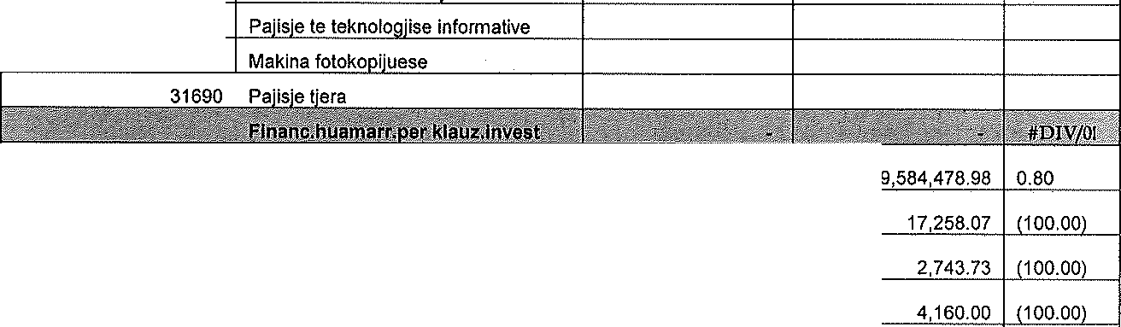

31250 I Kanalizimi

**13410 I Sherbimet e arsimit trajnimit**

31610

31650

#DIVLO!

11111

**a ave**

9,661,136.87

11115  **Pagesat eer sindikat/3 Antaresim-Oda e infermiereve te**

11125 **Kosoves**

11126 **Antareslm-Oda e miekeve te Kosoves**

11121 **Tatimi ne te ardh.oersonale** 686,587.30

11131 **Kontributl oensional-ounetori**

592,110.74

627,675.88 I 9.39

541,521.ao I 9.34

11151 Sindikatat

18,963.41

a,640.72 I

I

I

#DIV/0!

11152 **Odat profesionale**

#DIV/0!

|  |  |  |  |  |
| --- | --- | --- | --- | --- |
| 11211 | **Pervoia e nunes** | 508,097.96 |  | #DIV/0! |
| 11311 | **Kontributi nensional-nunMhensi** | 592,110.74 | 541,521.80 | 9.34 |
| 11411 | **Shtesa e venant ner te zniedhurit** | 30,428.18 |  | #DIV/0! |
| 11415 | **Shtesa per punen pa orar te naracaktuar** | 6,992.59 |  | #DIV/0! |
| 11416 | **Shtesa ner vellimin e nunes** | 2,744.43 |  | #DIV/0! |
| 11418 | **Shtesa per nepunesen/in e sistemit shend.** | 14,885.40 |  | #DIV/0! |
| 11431 | **Kujdestaria,puna gjate nates& puna iashte orarit te ounes** | 311,858.89 |  | #DIV/0! |
| 11611 | **Shtesat transitore** | 6,903.95 |  | #DIV/0! |
| 11900 | **Vendime ni"nesore** | 1,673,274.35 | 765,592.97 | 118.56 |
| 13130 | **Transporti per udhe. zyrtare brenda vendit** | 99.00 |  | #DIV/0! |
| 13131 | **Medit.udhl:i:t.zvrtar brenda vendit** |  |  | #DIV/0! |
| 13132 | **Akomodimi per udhe. zyrtare brenda vendit** | 14,177.90 |  | #DIV/0! |
| 13133 | **Shpenz.tjera udh.zyrtare brenda vendit** |  |  | #DIV/0! |
| 13140 | **Transporti per udhetime zyrtare jashte vendit** | 8,082.79 | 4,738.70 | 70.57 |
| 13141 | **Para xhepi/meditjet per udhetime zvrtare lashte vendit** | 1,340.00 | 670.00 | 100.00 |
| 13142 | Akomodimi-udh.zvrt.iasht vendit | 5,738.72 | 542.64 | 957.56 |
| 13143 | Shoenz.tiera udh.zvrtare iasht vendit | 1,833.46 | 507.01 | 261.62 |
| 13210 | Enerniia elektrike | 254,016.93 | 195,495.82 | 29.93 |
| 13220 | **Sherbimet e ujesjeUesit dhe**  **kanalizimit** | 46,171.47 | 18,874.29 | 144.63 |
| 13230 | **Mbeturinat** | 14,955.68 | 22,951.82 | (34.84) |
| 13250 | **Telefonia fikse** | 6,494.35 | 7,354.41 | (11.69) |
| 13260 | **Panesa-vendime ,.,i,,,.,esore** |  |  | #DIV/0! |
| 13310 | **Shnenz.oer internet** |  |  | #DIV/0! |
| 13320 | **Shnenz.e telefonise mobile** |  |  | #DIV/0! |
| 13330 | **Shnenzimet oostare** | 242.60 |  | #DIV/0I |
| 13410 | **Shn.e trainimit dhe arsimit** |  |  | #DIV/0! |
| 13420 | **Shnenz.e nerfan.&avokatures** |  |  | #DIV/0! |
| 13430 | **Sherb.te ndrvshme shendetesore** |  | 375.00 | (100.00) |
| 13440 | **Sherbimet keshilldhenese dhe nrofesionale** | 79,084.62 | 22,183.02 | 256.51 |
| 13450 | **Sherbimet e sht11nies/orintlmit** | 5,330.79 | 3,025.42 | 76.20 |
| 13460 | **Sherbimet kontraktuese tiera** | 239,820.63 | 366,518.31 | 134.57\ |
| 13470 | **Sherbiem teknike** | 40,868.99 | 32,752.31 | 24.78 |
| 13475 | **Sinurimi fizik I obiekteve nublike** | 19,857.60 |  | #DIV/0! |
| 13480 | **Shnenzimet e anetaresimit** | 15,000.00 |  | #DIV/0! |
| 13490 | **Sherbimet e varrimit** |  |  | #DIV/0! |
| 13501 | Mobilie |  |  |  |

|  |  |  |  |  |
| --- | --- | --- | --- | --- |
|  |  | 112,937.69 | 96,001.56 | 15.24 |
| 13502 | **Telefon me oak se 1000 euro** |  |  | #DIV/0! |
| 13503 | **Komoiuteret** | 166,333.20 | 3,460.00 | 5,311.87 |
| 13505 | **Makina fotokopjuese**  **/multifunksionale** | 976.60 |  | #DIV/0! |
| 13506 | **Paisie soeciale miekesore** |  |  | #DIV/0! |
| 13509 | **Paisie tiera** | 40,913.17 | 128,425.14 | /68.14) |
| 13510 | **Bleria e librave dhe venrave artistike** | 38,321.41 | 21,018.70 | 82.32 |
| 13610 | **Furnlzime ner zvre** | 5,532.37 | 31,220.15 | /82.28) |
| 13611 | **Furnizim me dokumenta bllanko** | 7,269.00 | 5,234.00 | 38.88 |
| 13616 | **Furnizim me artikui buinesor** | 45.00 |  | #DIV/0! |
| 13620 | **Furnizim ushqim dhe pijeOo dreka**  zvrtare\ | 155,746.58 | 244,533.79 | /36.31\ |
| 13630 | **Furnizime miekesore** | 129,319.62 | 157,619.37 | /17.95\ |
| 13640 | **Furnizimet e oastrimit** | 5,581.00 | 13,676.22 | /59.78) |
| 13650 | **Furnlzim me veshmbathie** |  | 14,735.00 | /100.00) |
| 13660 | **Akomodimi** |  |  | #DIV/0! |
| 13660 | **Tiketat sinuruesetbanderollat)** |  |  | #DIV/0! |
| 13710 | Vai |  |  | #DIV/0! |
| 13720 | NaM o r narohie nendrore | 22,590.25 | 38,468.93 | /41.26\ |
| 13750 | Qvmvr |  |  | #DIV/0! |
| 13760 | **Drute dhe prodhimet e drurit per narohie** | 221,086.47 | 407,699.10 | /45.77) |
| 13770 | **Derivate ner nienerator** |  |  | #DIV/0! |
| 13780 | **Derivate per automjete, gjenerator dhe makineri** | 57,418.40 | 69,368.68 | (17.23) |
| 13810 | **Avanc ner nara te imeta** | 500.00 | 1,000.00 | 150.00\ |
| 13820 | **Avanc oer udhetime z\1rtre** | (2,500.00\ | 9,211.00 | /127.14\ |
| 13950 | **Reaiistrim I automieteve** | 430.00 | 8,409.38 | /94.89\ |
| 13951 | **Siaurimi I automieteve** | 10,109.02 | 563,32 | 1,694.54 |
| 13952 | **Taksa komunale e reoiis.i auto.** |  |  | #DIV/0! |
| 13953 | **Si**□**urimi I ndertesave dhe te tiera** | 2,277.20 | 3,624.00 | (37.16) |
| 14010 | **Miremb.dhe rinarimi I automieteve** | 26,821.99 | 18,072.90 | 48.41 |
| 14020 | **Mirembai.e ndertesave** |  | 29,717.77 | 1100.00\ |
| 14022 | **Mirembai.e ndertesave admin.afariste** | 16,350.41 |  | #DIV/0! |
| 14023 | **Mirembaitia e ndertesave arsimore** | 113,339.52 | 29,253.60 | 287.44 |
| 14024 | **Mirembaitia eobiekteve shendetesore** | 23,482.37 | 1,277.65 | 1,737.93 |
| 14027 | **Mirembaitia e obiekteve kulturore** | 288.00 |  | #DIV/0! |
| 14030 | **Mirembaitia e auto rruneve** | 11,000.00 |  | #DIV/0! |
| 14032 | **Miremb.e rruneve lokale** | 132,842.04 | 270,960.92 | 150.97\ |
| 14040 | **Mirembaitie e teknoloniise informative** |  |  |  |

|  |  |  |  |  |
| --- | --- | --- | --- | --- |
|  |  |  | 70.00 | (100,00) |
| 14050 | **Mlrembai.e mobileve dhe oaisieve** | 60,728.91 | 7,140.41 | 750,50 |
| 14060 | **Mirembaitla rutinore** | 9,125.00 | 55,366.27 | (83.52) |
| 14110 | **Qiraia per ndertesa** |  | 3,036.44 | (100.00) |
| 14120 | **Qiraia oer toke** | 16,986.57 | 1,518.00 | 1,019.01 |
| 14130 | Qiraja per paisie | 150.00 | 1,622.40 | (90.75) |
| 14140 | **Qiraia-makineria** |  |  | #DIV/0! |
| 14150 | **Qiraia- oerdorime tiera te haoesirave** |  | 3,036.19 | /100.00) |
| 14210 | **Reklamat dhe konkurset** |  |  | #DIV/0! |
| 14220 | **Botimet e oubllklmeve** |  |  | #DIV/0! |
| 14230 | Shp.per infor.pub. | 7,939.50 | 5,000.00 | 58.79 |
| 14310 | **Kompensimi I perfaqesimlt brenda**  vendil(dreka zvrtare) | 4,496.20 | 2,944.40 | 52,70 |
| 14410 | **Vendimet e oivnesore** | 185,390.85 | 58,558.10 | 216.59 |
| 14420 | Paoesa-neni 39.2 LMFPP |  |  | #DIV/0! |
| 21110 | Sho.oer enlit.oublike |  |  | #DIV/0! |
| 21200 | **Sub.oer entitete iooublike** | 191,303.01 | 161,660.00 | 18.34 |
| 22200 | **Paaesa oer oerfituesit individual** |  | 89,600.00 | /100.00) |
| 31110 | **Ndertesat e banimit** |  |  | #DIV/0! |
| 31120 | **Ndertesat adminis.afariste** |  |  | #DIV/0! |
| 31121 | **Obiektet arsimore** | 250,209.86 | 630,963.96 | (60.34) |
| 31123 | Obiektet kulturore | 25,170.83 | 14,142.77 | 77.98 |
| 31124 | Obiektet soortive |  |  | #DIV/0! |
| 31125 | Obiektet memoriale |  |  | #DIV/0! |
| 31126 | Rrethoia |  |  | #DIV/0! |
| 31129 | **Fushat e soortit** | 172,372.81 | 4,934.76 | 3,393.03 |
| 31122 | **Ndertesat shendetesore** | 3,527.49 | 22,713.33 | (84.47) |
| 31136 | **Urat** | 54,369.07 |  | #DIV/0! |
| 31125 | **Monumentet dhe komplekset memoriale** | 49,500.00 |  | #DIV/0I |
| 31230 | **Rruaet lokale** | 1,600,850.11 | 787,749.68 | 103.22 |
| 31240 | **Trotuaret** | 179,527.90 | 124,314.18 | 44.41 |
| 31250 | **Rrietet e kanalizimit** | 46,852.33 | 110,948.33 | /57.77) |
| 31260 | Rrjetet e ujesjellesit | 60,000.00 |  | #DIV/0! |
| 31270 | **Mirembaitia e investimeve** |  | 214,999.60 | (100,00) |
| 31510 | **Furniz.me rryme,gjenerim,transmision- ndriqimi**  oublik |  |  | #DIV/0! |
| 31640 | **Komoiuter** |  |  | #DIV/0! |
| 31660 | **Paisie mjekesore** | 80,000.00 | 100,970.00 | /20.77) |
| 31690 | **Paisie tiera** |  |  | #DIV/0! |

|  |  |  |  |  |
| --- | --- | --- | --- | --- |
| 31703 | **Vetura e ndihmes se shoeite** |  | 146,620.00 | 1100.00\ |
| 31900 | Kapital tjeter |  |  | #DIV/0! |
| 31260 | Uiesiellesi |  |  | #DIV/0! |
| 31620 | Mobil'e |  |  | #DIV/0! |
| 31690 | **Paisie tiera** |  |  | #DIV/0! |
| 31700 | **Vetura zvrtare** |  |  | #DIV/0! |
| 32000 | **lnvestimet ne viiim** |  |  | #DIV/0! |
| 32100 | Toka | 656,554.00 | 250,000.00 | 163.42 |
| 32110 | **Shtreterit e lemenjeve** | 406,645.24 | 350,000.00 | 16.16 |
| 32140 | Parqet dhe hapesirat publike | 70,665.34 | 150,000.00 | (52.69) |
| 33100 | **Trans.kao.-entitetet oublike** |  |  | #DIV/0! |
| 33200 | **Trans.kaoitale -entitetet iooublike** |  |  | #DIV/0! |
| 34000 | **Paaest sioas vendime nh,nesore** | 619,692.37 |  | #DIV/0! |
| 34100 | Pa esa neni 39.2 LMFPP |  |  | #DIV/OI |

,a

|  |  |  |  |  |
| --- | --- | --- | --- | --- |
| 11110 | **Pagat neto oermes listes se pagave** |  | 61,172.50 | (100.00) |
| 13141 | **Meditie-udhetim zvrtar iasht vendit** |  |  | #DIV/0! |
| 13460 | **Sherb.kontraktuese tlera** |  | 3,423.45 | (100.00) |
| 13501 | **Mobil'e me oak se 1000 euro** |  |  | #DIV/0! |
| 13509 | Pailsie tiera<1000 |  | 2,007.06 | 1100.00\ |
| 13610 | **Furnlzime oer zvre** |  |  | #DIV/0! |
| 13620 | **Furnizim me ushqim dhe pijeQo dreka**  zyrtare) |  | 3,336.76 | (100.00) |
| 13720 | Nafte per nqrohie qendrore |  |  | #DIV/0! |
| 13760 | Dru |  | 6,569.57 | (100.00) |
| 13950 | **Rexhistrimi I automieteve** |  |  | #DIV/0! |
| 14023 | **Mirembaitie e shkollave** |  |  | #DIV/0! |
| 14110 | QlraJa per ndMesa |  |  | #DIV/0! |
| 14310 | **Dreka zvrtare** |  |  | #DIV/0! |
| 14410 | **Shoenzime-vendimet e nivkatave** |  | 2,322.43 | (100.00) |
| 21110 | **Sub.oer entitete oublike** | 30,000.00 | 20,640.00 | 45.35 |
| 21120 | **Sub.oar entitete kulturore** |  |  | #DIV/0! |
| 21200 | **Sub.oer entitete iooublike** | 406,000.16 | 352,596.47 | 15.15 |
| 22200 | **Paa.oer oerfituesit individual** |  | 109,000.00 | 1100.00\ |
| 31120 | **Ndertesat adminis.afariste** |  |  | #DIV/0! |
| 31123 | Obiektet kulturore |  |  | #DIV/0! |
| 31124 | Obiektet sportive |  |  | #DIV/0! |
| 31230 | **Rruaet lokale** | 6,579.40 |  | #DIV/0! |
| 31240 | **Trotuaret** |  |  | #DIV/0! |
| 31250 | **Kanalizimi** |  |  | #DIV/0! |
| 32100 | Toka |  |  | #DIV/0! |
| 32110 | **Rreoullimi I lemenieve** |  |  | #DIV/0! |
| 32050 | **Financim me IPA** |  |  | #DIV/0! |

|  |  |  |  |  |  |
| --- | --- | --- | --- | --- | --- |
| 32110 | **Rreaullimi I lemenieve** |  |  | #DIV/0! | |
| 32100 | **Toka- shoronedsimi** |  |  | #DIV/0! | |
|  |  |  |  | 18.52 | |
| 13210 | **Eneraiia elektrike** | 14,667.50 I |  | I #DIV/0! | |
|  | **Shoenzlmet e ujesjellesit dhe** |  |  |  | |
| 13220 | **kanalizimit** | 12,372.57 |  | #DIV/0! | |
| 13260 | **Paaesat- vendime ni\inesore** | 11,136.74 |  | #DIV/0! | |
| 13501 | **Mobire me nak se 1000 euro** |  |  | #DIV/0! | |
| 21200 | **Sub.ner entitete ionublike** | 123,345.70 |  | #DIV/0! | |
| 22100 | **Transfere ner Qeveri tiera** |  |  | #DIV/0! | |
| 22200 | Paa.oer oMituesit individual |  |  | #DIV/0! | |
| 31110 | **Ndertesat e banimit** |  |  | #DIV/0! | |
| 31120 | **Ndertesat administrative afarlste** | 181,877.53 | 129,448.00 | 40,50 | |
| 31121 | **Obiektet arsimore** |  |  | #DIV/0! | |
| 31122 | **Obiektet shendetesore** |  |  | #DIV/0! | |
| 31124 | Obiektet soortive |  | 23,104.84 | (100.00 | |
| 31126 | **Rrethoia** |  |  | #DIV/0! | |
| 31128 | **Garazha** |  |  | #DIV/0! | |
| 31230 | Rruoet lokale | 142,407.00 | 42,655.93 | 233.85 | |
| 31240 | **Trotuaret** |  |  | #DIV/0! | |
| 31250 | **Kanalizlmi** |  |  | #DIV/0! | |
| 31270 | **Mirembaitia e investimeve** |  |  | #DIV/0! | |
| 32100 | Takai | 18,096.00 |  | #DIV/0! | |
| 32110 | **Rreaullimi I lemenieve** |  |  | #DIV/0! | |
|  |  |  |  | #DIV/0! | |
|  |  |  |  |  | 398.80 |
| 13460 | **Sherbime kontraktuese tiera** |  |  |  | #DIV/0! |
| 21200 | **Subvencionet oer entitetet iooublike** | 120,410.00 |  |  | #DIV/0! |
| 22200 | **Paa.oer oerfituesit individual** |  |  |  | #DIV/0! |
| 31122 | **Obiektet shendetesore** |  |  |  | #DIV/0! |
|  |  |  |  |  | #DIV/0! |
|  |  |  |  |  | #DIV/0! |
|  | | | | | 21,77 |

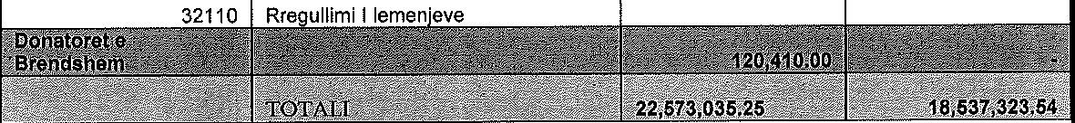



**Shpenzimet sipas programeve janar-shtator 2024**

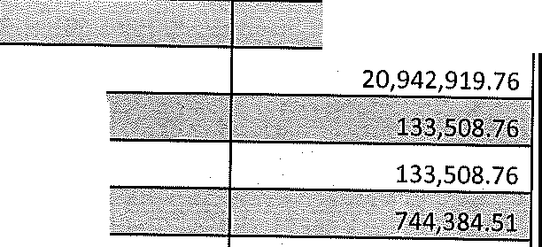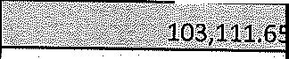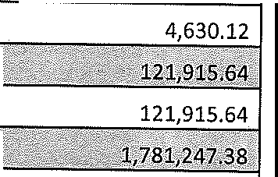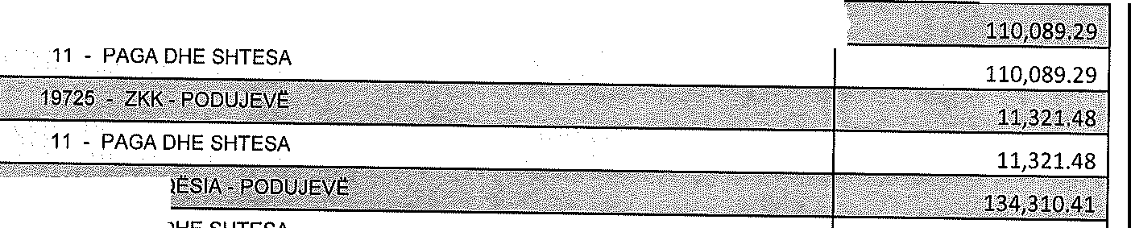

1..0 - suxH. ,;r

615 - PODUJEVt:

<.,"<_,-i-,2,, ,0, ,, 9,, 4,,, 2,,,9,,]9,., ;,,7,,,6,,

11 - PAGA DHE SHTESA

11 - PAGA DHE SHTESA

13 - MALLRA DHE SHt:RBIME

14 - SHPENZIME KOMUNALE

333,294.56

208,103.31

202,986.64

11 - PAGA DHE SHTESA

103,111.65

11 - PAGA DHE SHTESA

13 - MALLRA DHE SHt:RBIME

240,631.84

11 - PAGA DHE SHTESA

11 - PAGA DHE SHTESA

13 - MALLRA DHE SHt:RBIME

30 - PASURITt: JOFINANCIARE

60,618.99

479,362.59

1,241,265.80

20 - SUBVENCIONE DHE TRANSFERE I 89,403.01I



··••

· *<!*

*e*,

|  |  |  |
| --- | --- | --- |
| **11** - PAGA DHE SHTESA | I | 42,026.97 |
| 13 - MALLRA DHE SHt:RBIME | I | 2,880.43 |

:g.:;wftr t@.1B1 isrMl•*i J1!11,%¥ffllp,vst%wiiii4ir2·y>F','; ®2

11 - PAGA DHE SHTESA 61,195.55

13 - MALLRA DHE SHt:RBIME 5,140.69

30 - PASURITt: JOFINANCIARE 707,430.34

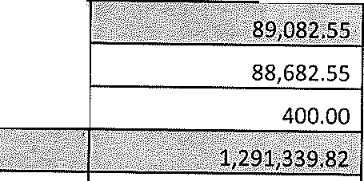

11 - PAGA DHE SHTESA

13 - MALLRA DHE SHt:RBIME

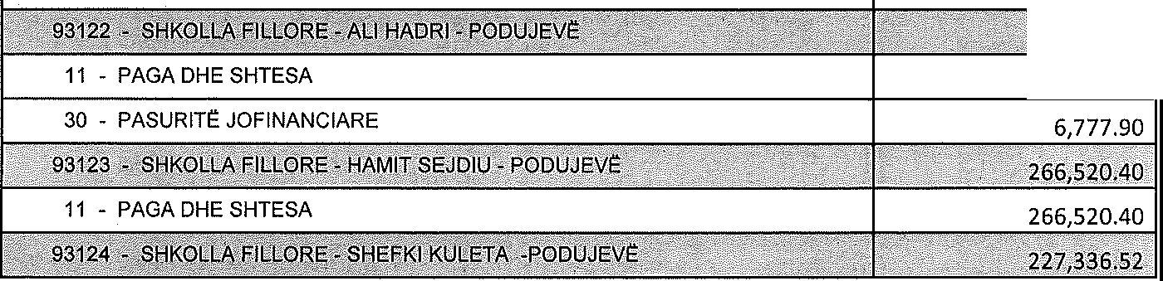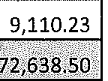

265,860.60

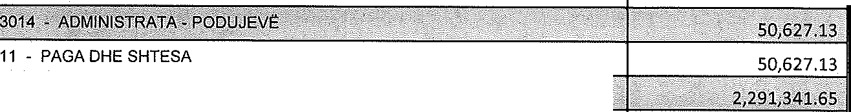

30 - PASURITE JOFINANCIARE 83,527.49

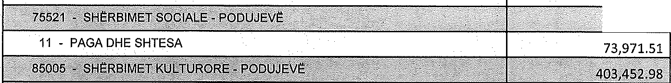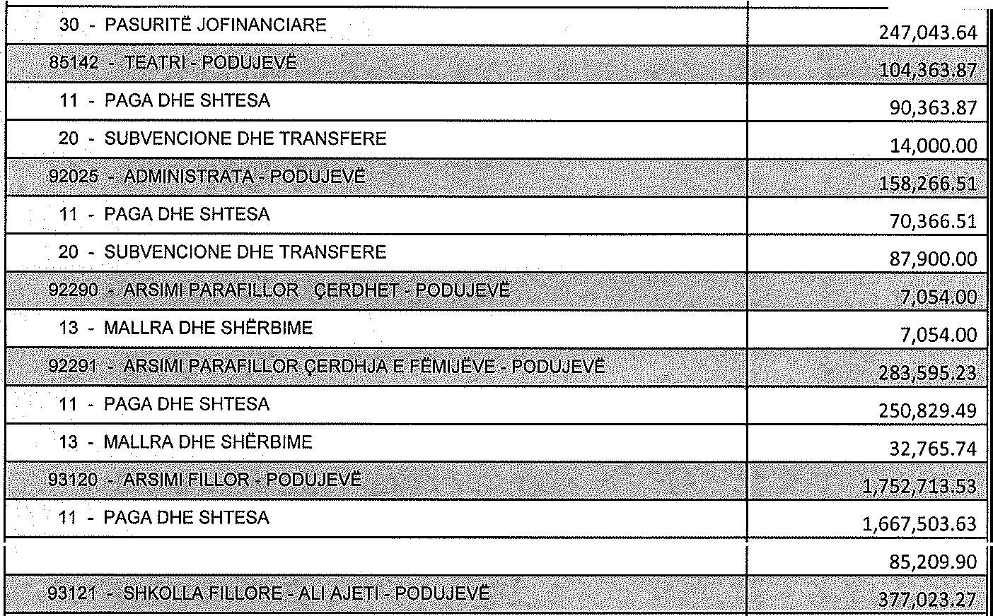

1;:ii ¥i.s1

11 • PAGA DHE SHTESA

13 • MALLRA DHE SHERBIME

100,002.34

56,407.00

30 • PASURITE JOFINANCIARE

|  |  |
| --- | --- |
| 13 • MALLRA DHE SHERBIME | 84,139.13 |
| 30 • PASURITE JOFINANCIARE | 1,128,767.85 |
| *··*•·*·*.*·: R6:1 vP Wt£ar rf¥ Q&*'m•ehiwf*R,{ $ o # "°s{-•PQ[?uJl= t; *,.)*  11 • PAGA DHE SHTESA | 1,802,570.10 |
| 13 • MALLRA DHE SHERBIME | 369,475.71 |
| 14 • SHPENZIME KOMUNALE | 35,768.35 |
|  | |

|  |  |
| --- | --- |
| 11 • PAGA DHE SHTESA | 360,626.27 |
| 13 • MALLRA DHE SHERBIME | 7,286.77 |
| 14 • SHPENZIME KOMUNALE |  |

11 • PAGA DHE SHTESA 227,336.52

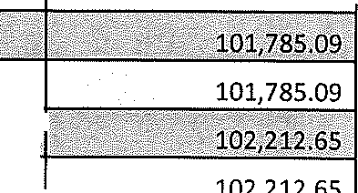

•

1•

,'

> ,

1

11 - PAGA DHE SHTESA

11 - PAGA DHE SHTESA

:?;zf 9Jf , g ggti[{i Jlct E <?'.a 'l; KQM i-( ,#§,ciy \/ra <

11 - PAGA DHE SHTESA 196,955.88

11 - PAGA DHE SHTESA

11 - PAGA DHE SHTESA

83,185.06

11 - PAGA DHE SHTESA I 329,449.78

11 - PAGA DHE SHTESA

11 • PAGA DHE SHTESA

13 - MALLRA DHE SHE:RBIME

11 - PAGA DHE SHTESA

11 - PAGA DHE SHTESA

187,801.01

155,771.76

105,480.76

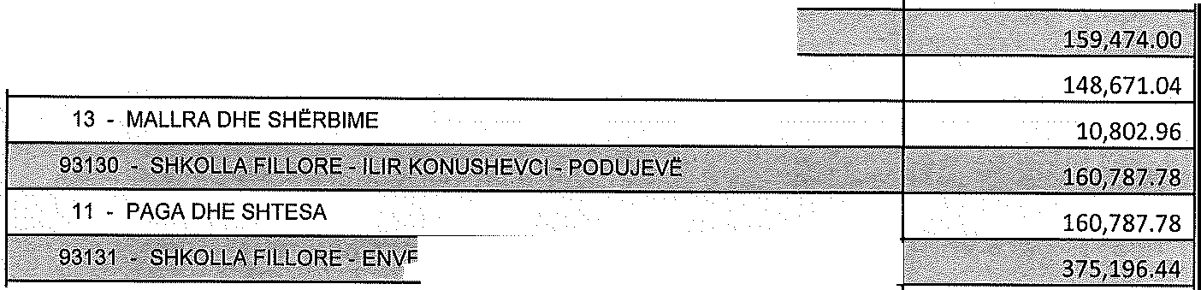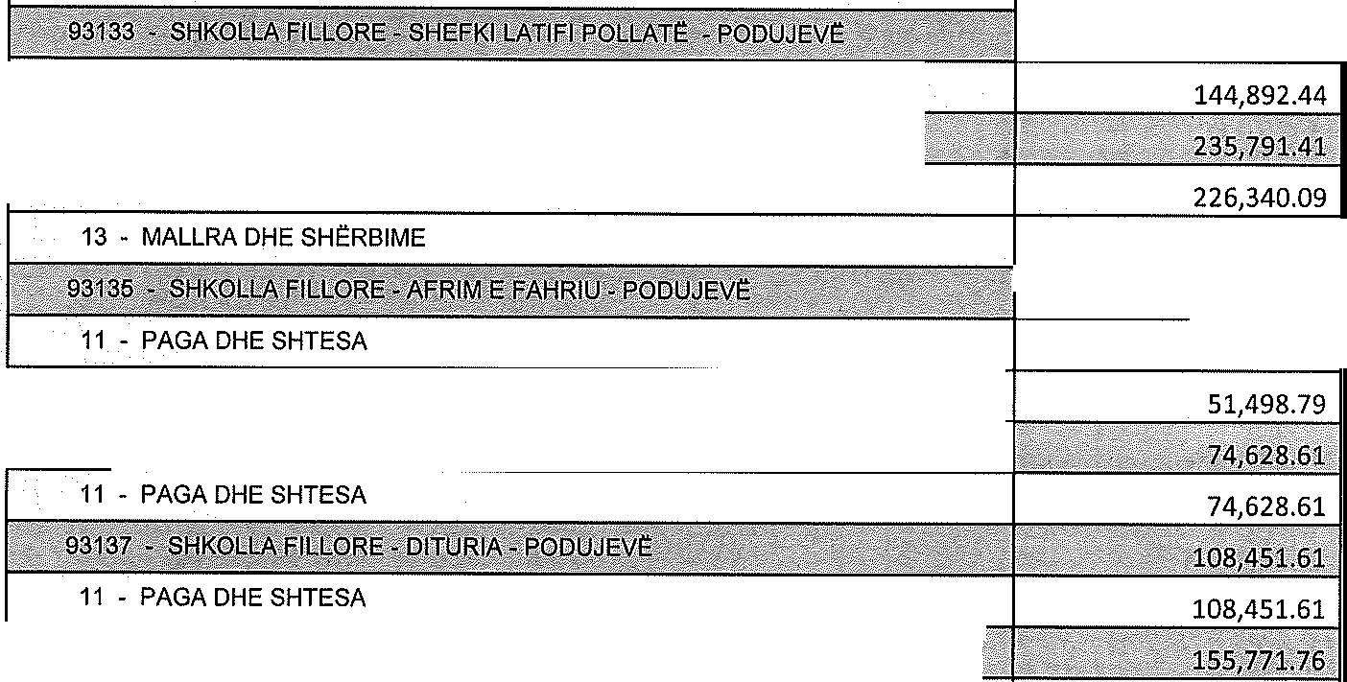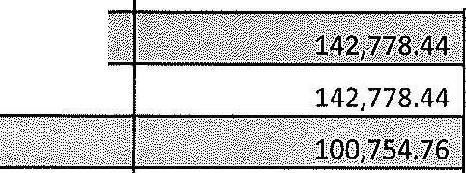

11 - PAGA DHE SHTESA

. 9)i{il.li8

11 - PAGA DHE SHTESA

11 • PAGA DHE SHTESA

13 - MALLRA DHE SHERBIME

11 • PAGA DHE SHTESA

'if:J¥:{,aiE sf{s E JiwitooRifit e VfquJiq @ W$r ili. y···•·, .

11 - PAGA DHE SHTESA

30 • PASURITE JOFINANCIARE

•,2a&r9;z ,.1ir

11 - PAGA DHE SHTESA 177,331.26

13 - MALLRA DHE SHERBIME

--,

|  |  |  |
| --- | --- | --- |
|  | | '. ;< 3  6Zi19\Jli,J ..• |
| 11 - PAGA DHE SHTESA | ' | 404,601.94 |
| 13 - MALLRA DHE SHERBIME | I | 92,418.89 |
| 14 - SHPENZIME KOMUNALE | I | 68,047.60 |
| 30- PASURITE JOFINANCIARE | """""""""""",:,;f;"""""",;;-, | 107,926.90 |

11 - PAGA DHE SHTESA 728,595.63

13 - MALLRA DHE SHERBIME 14,659.51

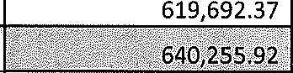30 - PASURITE JOFINANCIARE

11 • PAGA DHE SHTESA 574,119.92

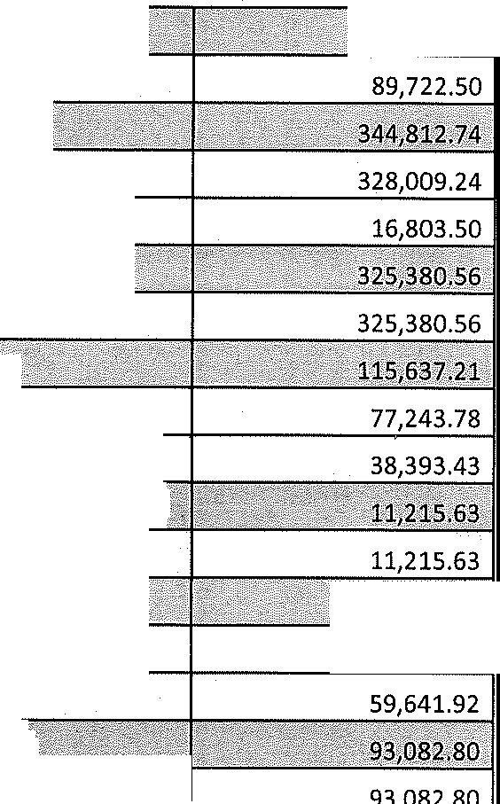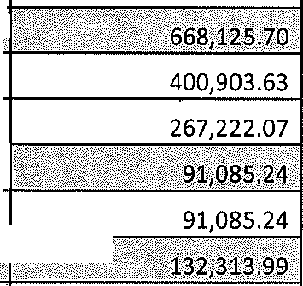

13 - MALLRA DHE SHERBIME

11 - PAGA DHE SHTESA

13 - MALLRA DHE SHERBIME

11 - PAGA DHE SHTESA

638,695.37

10,965.00

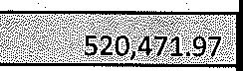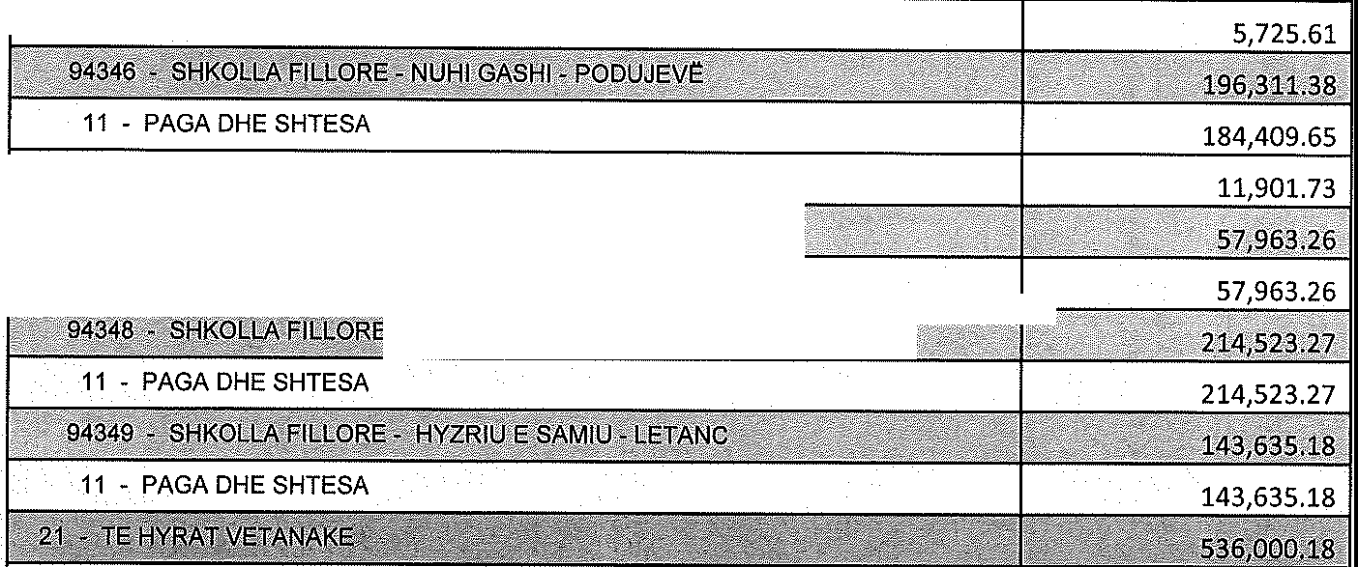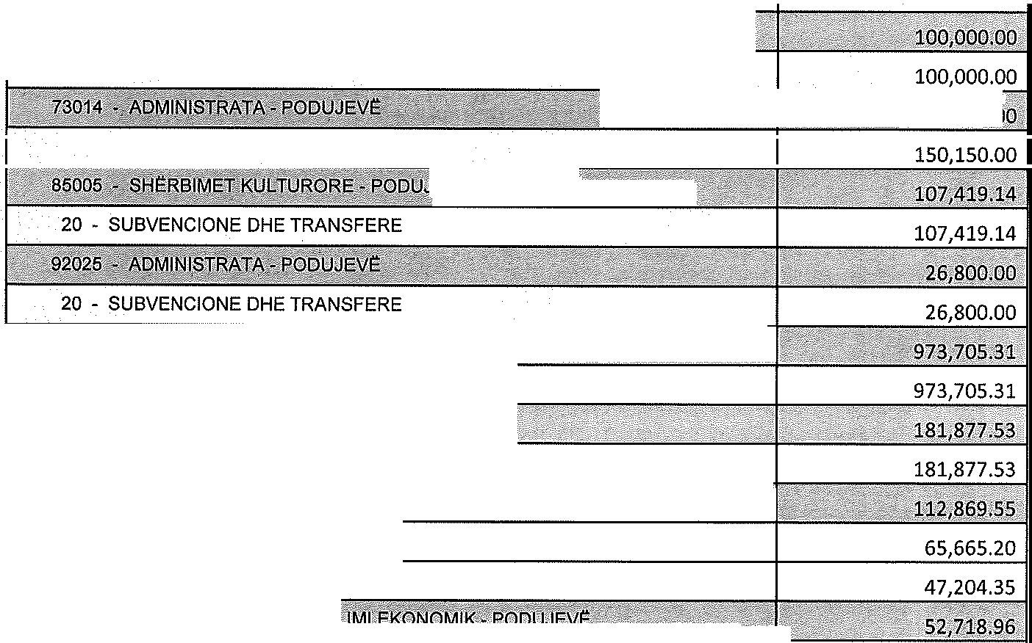

380,433.03

13 - MALLRA DHE SHERBIME

134,313.33

11 - PAGA DHE SHTESA

14 - SHPENZIME KOMUNALE

30 - PASURITE JOFINANCIARE

615 - PODUJEVE ' 536,000.18

30 - PASURITE JOFINANCIARE

20 - SUBVENCIONE DHE TRANSFERE

615 - PODUJEVE

30 - PASURITE JOFINANCIARE

20 - SUBVENCIONE DHE TRANSFERE

30 - PASURITE JOFINANCIARE

*L,,:,,¼Y£QR!dd,dk"'"'''' '02(f 1!1'.'5'(t,+x:::xrYFZ'Y :sc2c::n;;;, :7c:* "'· · *'•:* I

20 - SUBVENCIONE DHE TRANSFERE

|  |  |  |
| --- | --- | --- |
|  |  | 52,718.96 |
| 512,861.00 |
|  |  | |



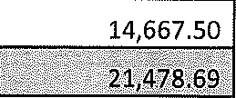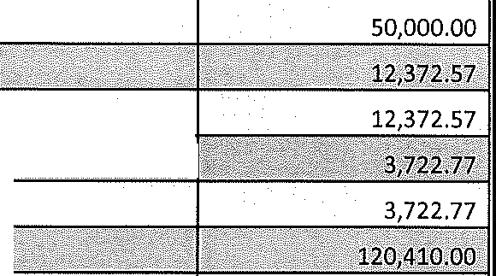

14 - SHPENZIME KOMUNALE

20 - SUBVENCIONE DHE TRANSFERE

4,961.54

16,517.15

11,136.74

30 - PASURITI= JOFINANCIARE

14 - SHPENZIME KOMUNALE

30 - PASURITI= JOFINANCIARE

615 • PODUJEVI=

**,a:ii'i!**

20 - SUBVENCIONE DHE TRANSFERE

86,960.00

20 - SUBVENCIONE DHE TRANSFERE

33,450.00

14 - SHPENZIME KOMUNALE

30 - PASURITI= JOFINANCIARE

Talimi ne toke

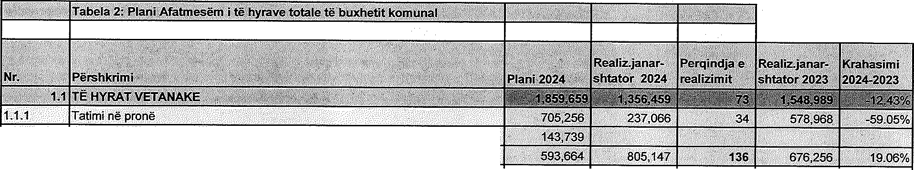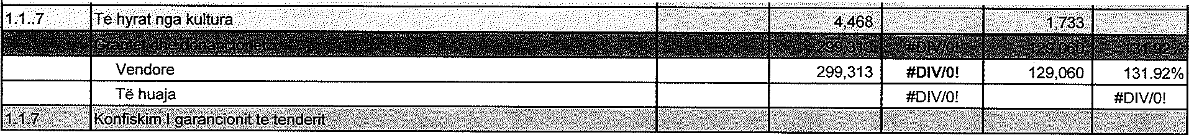

1.1.2 Taksat komunale

Licencat dhe lejet 130,757 6,041 5 3,417 76.81%

|  |  |  |  |  |  |  |
| --- | --- | --- | --- | --- | --- | --- |
| 1.1.3 | Certifikatat dhe dokumentet zyrtare 100,000 65,202 **65** 80,521 -19.02%  Taksat e paisjeve motorike(gjobat ne trafik, regj.i auto., agjens.i pyjeve) 100,000 346,481 346 305,052 13.58%  Lejet per ndertesa 208,664 275,131 **132** 155,866 76.52%  Taksat tjera komun.(aktiv.gjeo. dhe sherb.e inspektimit) 54,243 112,292 207 131,400 -14.54% Takse per mbeturina  Ngarkesat komunale 267,000 258,069 ***' ti* -·236,363 9.18%** | | | | | |
|  | Ngarkesat rregullatore |  |  | #DIV/0! |  | #DIV/0! |
|  | Te hyrat nga qiraja(shfry1.i prones komunale) | 120,000 | 71,663 | **60** | 77,519 | -7.55% |
|  | Bashke-pagesat per arsim | 75,000 | 120,945 | 161 | 92,205 | 31.17% |
|  | Bashke-pagesat per shendetesi | 72,000 | 65,462 | **91** | 66,639 | -1.77% |
|  | Ngarkesat tjera komunale |  |  | #DIV/0! |  | #DIV/0! |
| **1.1.4** | Te hyrat tjera(te ardhurattjera-taksat administrative) | **·.t56,Q0O** | **23,464** | **16.** | 30,874 | -:14:00% |

* + 1. Gjobat e gjykates .,28,245 #DIV/0! 13_:9J%
    2. **#DIV/0!** #DIViO!

P.S **Realizimi I te hyrave vetanake pa donacione**